Laporan Spesifikasi & Kondisi Laptop Kantor

(*Serta Rekomendasi untuk penambahan SSD*)

1. **LAPTOP LENOVO 20RV (THINKBOOK)**

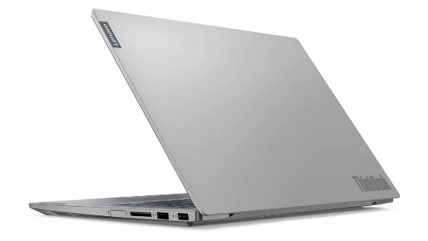

* Sistem Operasi : Windows 11 Pro
* Tipe Laptop : Lenovo 20RV (ThinkBook)
* Kondisi Laptop : Bagus (Tidak ada kendala/kerusakan).
* Spesifikasi Laptop :

|  |  |
| --- | --- |
| Processor | Intel ® Core ™ i7-10510 CPU@1.80Ghz (8 CPUs) |
| GPU | Intel UHD Graphics  AMD Radeon (TM) 625 |
| RAM | 8GB DDR4 (Up to 24GB) |
| Storage | 1 TB HDD (Used 40GB) |

Performa Laptop (Ketika membuka banyak tab & aplikasi) :

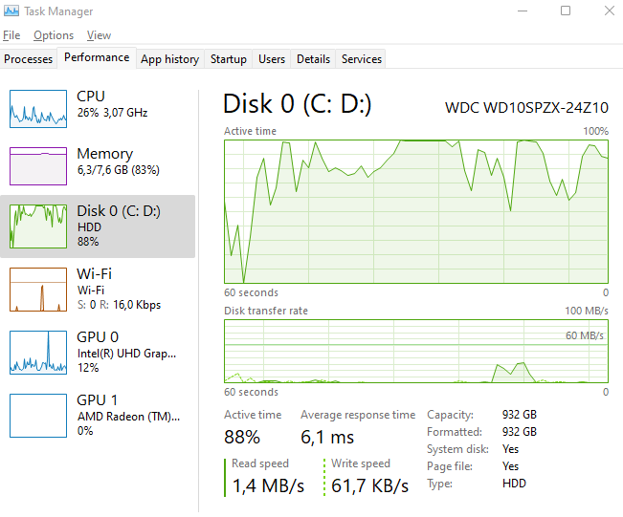

Rekomendasi penambahan SSD untuk Laptop LENOVO 20RV

|  |  |
| --- | --- |
|  | M.2 NVME  MIDASFORCE  128GB + baut(Rp.185.000)  256GB + baut(Rp.263.000)  <https://tokopedia.link/Hov7kNOYCzb> |

1. **LAPTOP ASUS K46CM**

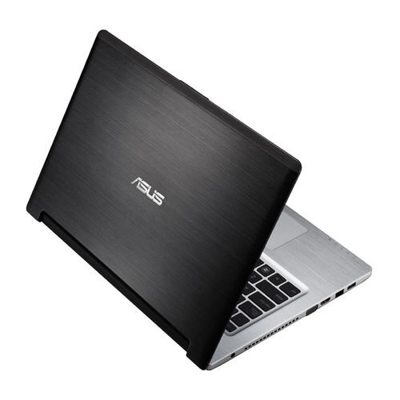

* Sistem Operasi : Windows 10 Pro
* Tipe Laptop : AsusTek Computer INC K46CM
* Kondisi Laptop : Bagus, Minus Charger Laptop rusak.
* Spesifikasi Laptop :

|  |  |
| --- | --- |
| Processor | Intel ® Core ™ i7-3517U CPU@1.90Ghz (4 CPUs) |
| GPU | NVIDIA GeForce GT 635M |
| RAM | 4GB + 4GB DDR3 (Max 8GB) |
| Storage | 750 GB HDD (Used 102GB) |

Performa Laptop (Ketika membuka banyak tab & aplikasi) :

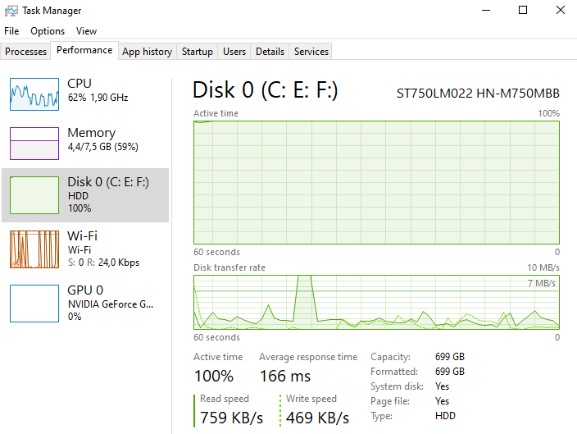

Rekomendasi penambahan SSD untuk Laptop ASUS K46CM

|  |  |
| --- | --- |
|  | SSD SATA III  MIDASFORCE  128GB + Caddy 9,5 (Rp.151.000)  256GB + Caddy 9,5 (Rp.211.000)  <https://tokopedia.link/AflmOKT4Czb> |
|  | Adaptor Charger Laptop  Asus K46CM 19v-3.42a  (Rp.80.000)  <https://tokopedia.link/Tnopp2WfEzb> |

1. **LAPTOP DELL INC. VOSTRO 3478**

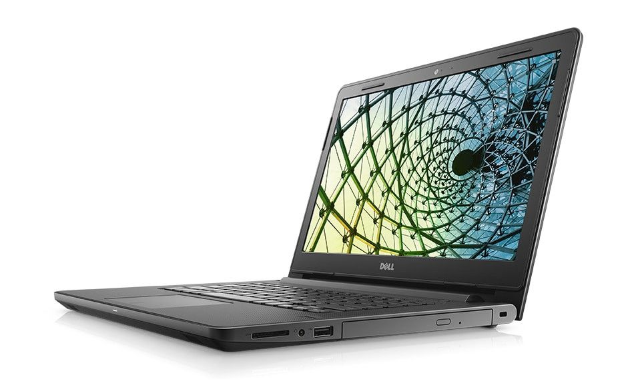

* Sistem Operasi : Windows 10 Home Single Language
* Tipe Laptop : Dell Inc. Vostro 3478
* Kondisi Laptop : Bagus
* Spesifikasi Laptop :

|  |  |
| --- | --- |
| Processor | Intel ® Core ™ i5-8250U CPU@1.60 Ghz (8 CPUs) |
| GPU | Intel® UHD Graphics 620  Radeon ™ 520 |
| RAM | 4GB DDR4 (Up to 16GB) |
| Storage | 1 TB HDD (Used 61GB) |

Performa Laptop (Ketika membuka banyak tab & aplikasi) :

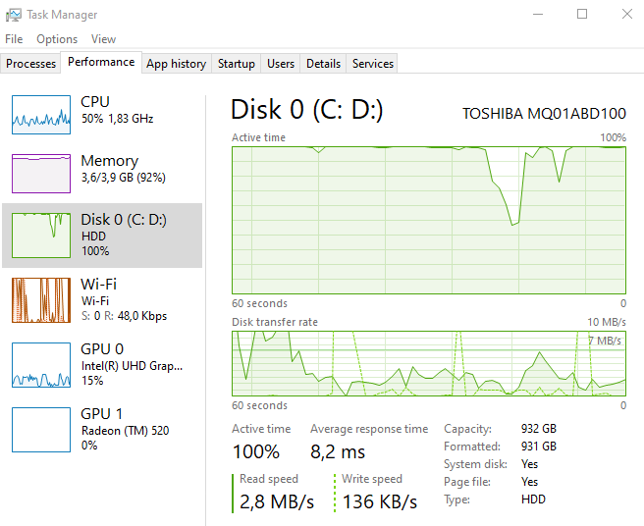

Rekomendasi penambahan SSD untuk Laptop Dell Inc. Vostro 3478

|  |  |
| --- | --- |
|  | SSD SATA III  MIDASFORCE  128GB + Caddy 9,5 (Rp.151.000)  256GB + Caddy 9,5 (Rp.211.000)  <https://tokopedia.link/AflmOKT4Czb> |

1. **LAPTOP HP PROBOOK 4421s**

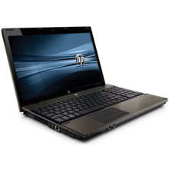

* Sistem Operasi : Windows 7 Ultimate
* Tipe Laptop : HP Probook 4421s
* Kondisi Laptop : Body sudah ada yang terangkat

Keybind (2, w, s, dan x) tidak berfungsi.

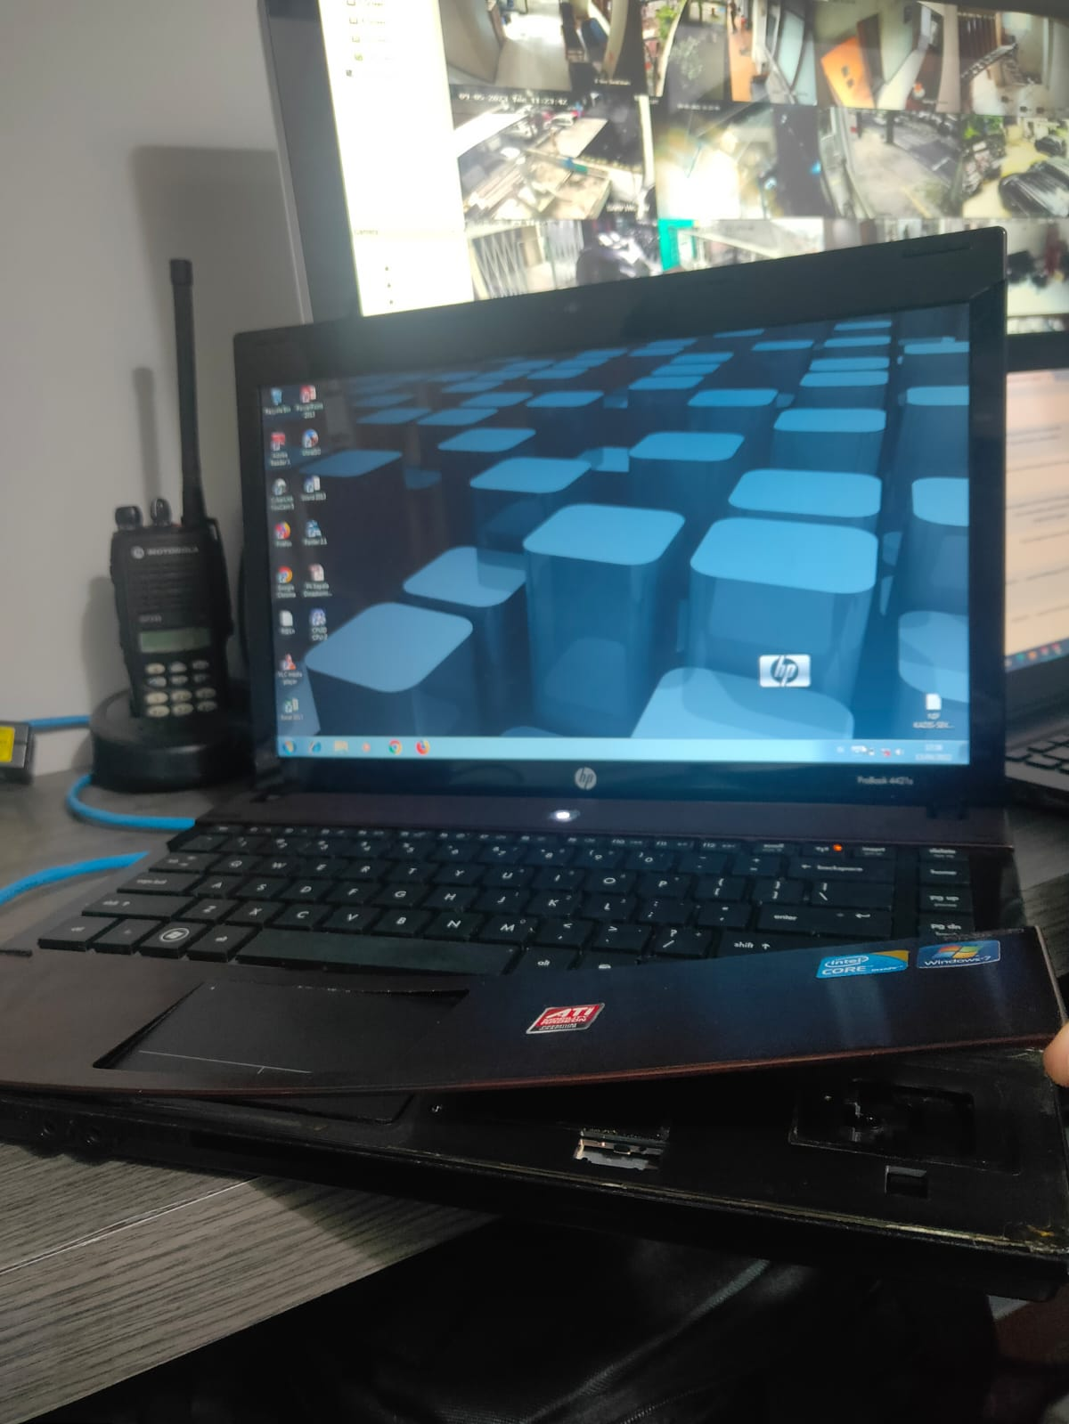

* Spesifikasi Laptop :

|  |  |
| --- | --- |
| Processor | Intel ® Core ™ i5 CPU 480M @2.67 Ghz 2 Core(s), 4 Logical Processor |
| GPU | ATI Mobility Radeon HD 6370 |
| RAM | 2GB DDR3 (Up to 8GB) |
| Storage | Deskripsi Google 320GB  Di File Explorer 97 + 368 (465GB)  (Used 25GB) |

Performa Laptop (Ketika membuka banyak tab & aplikasi) :

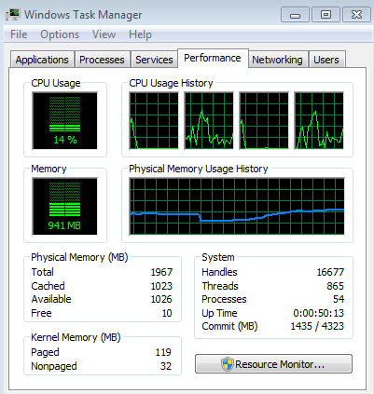

Rekomendasi penambahan SSD untuk Laptop HP Probook 4221s

|  |  |
| --- | --- |
|  | SSD SATA III  MIDASFORCE  128GB + Caddy 12,7 (Rp.151.000)  256GB + Caddy 12,7 (Rp.211.000)  <https://tokopedia.link/AflmOKT4Czb> |